ONLINE HOLIDAY MARKETPLACE

THIS YEAR WE WILL BE HOSTING AN ONLINE HOLIDAY MARKETPLACE IN ADDITION TO OUR BOUTIQUE AT OUR CLUBHOUSE ON DECEMBER 6TH.

WE HOPE YOU WILL SHOP FOR YOUR HOLIDAY GIFTS TO FIND THE PERFECT GIFT AS OUR WOMAN’S CLUB WILL BE RECEIVING 10% COMMISSION FOR ALL ITEMS SOLD. ALL OF OUR VENDORS HAVE GUARANTEED DELIVERY BEFORE CHRISTMAS. PLEASE FEEL FREE TO SHARE THIS EMAIL WITH YOUR FAMILY & FRIENDS.

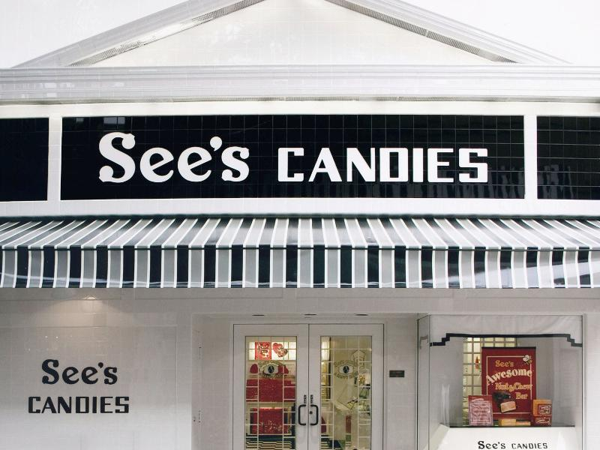

Please use the link below to order your candies for holiday gift giving:
https://www.yumraising.com/store/winter-2025-womans-club-of-bethesda-7a1a/MarShe7261

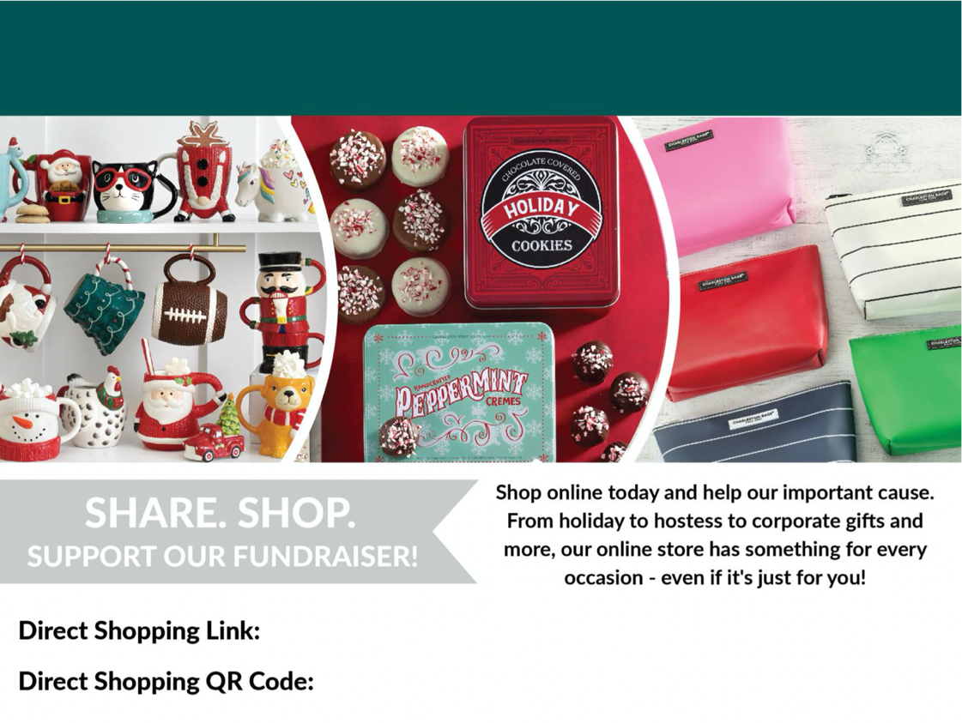
https://registercw.com/gateway?organizationMidasId=27240

https://midas.charlestonwrap.com/qrcode.htm#27240-2025F

